Python Cheat Sheet

Mosh Hamedani
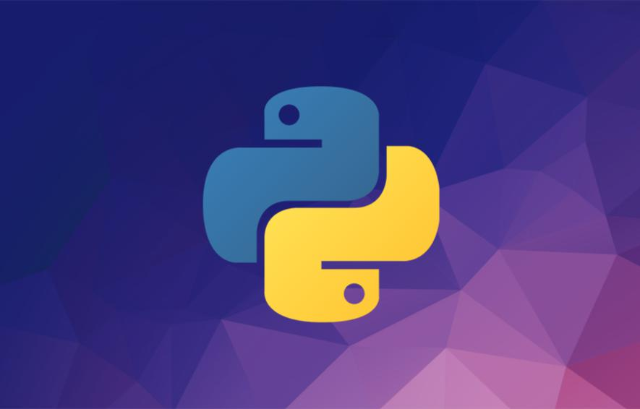

Code with Mosh (codewithmosh.com)

1st Edition

About this Cheat Sheet

This cheat sheet includes the materials I’ve covered in my Python tutorial for Beginners on YouTube. Both the YouTube tutorial and this cheat cover the core language constructs but they are not complete by any means.

If you want to learn everything Python has to offer and become a Python expert, check out my Complete Python Programming Course:

http://bit.ly/complete-python-course
About the Author



Hi! My name is Mosh Hamedani. I’m a software engineer with two decades of experience and I’ve taught over three million how to code or how to become a professional software engineer. It’s my mission to make software engineering simple and accessible to everyone.

https://codewithmosh.com https://youtube.com/user/programmingwithmosh https://twitter.com/moshhamedani https://facebook.com/programmingwithmosh/
Variables 5

Comments 5

Receiving Input 5

Strings 6

Arithmetic Operations 7

If Statements 8

Comparison operators 8

While loops 8

For loops 9

Lists 9

Tuples 9

Dictionaries 10

Functions 10

Exceptions 11

Classes 11

Inheritance 12

Modules 12

Packages 13

Python Standard Library 13

Pypi 14

Want to Become a Python Expert? 14
Variables

We use variables to temporarily store data in computer’s memory.

price = 10

rating = 4.9

course_name = ‘Python for Beginners’

is_published = True

In the above example,

- price is an integer (a whole number without a decimal point)

- rating is a float (a number with a decimal point)

- course_name is a string (a sequence of characters)

- is_published is a boolean. Boolean values can be True or False.

Comments

We use comments to add notes to our code. Good comments explain the hows and whys, not what the code does. That should be reflected in the code itself. Use comments to add reminders to yourself or other developers, or also explain your assumptions and the reasons you’ve written code in a certain way.

- This is a comment and it won’t get executed.

- Our comments can be multiple lines.

Receiving Input

We can receive input from the user by calling the input() function.

birth_year = int(input(‘Birth year: ‘))

The input() function always returns data as a string. So, we’re converting the result into an integer by calling the built-in int() function.

Strings

We can define strings using single (‘ ‘) or double (“ “) quotes.

To define a multi-line string, we surround our string with tripe quotes (“””).

We can get individual characters in a string using square brackets [].

course = ‘Python for Beginners’

course[0] | # returns the first character
course[1] | # returns the second character
course[-1] | # | returns | the first character from the end
course[-2] | # | returns | the second character from the end

We can slice a string using a similar notation:

course[1:5]

The above expression returns all the characters starting from the index position of 1 to 5 (but excluding 5). The result will be ytho

If we leave out the start index, 0 will be assumed.

If we leave out the end index, the length of the string will be assumed.

We can use formatted strings to dynamically insert values into our strings:

name = ‘Mosh’

message = f’Hi, my name is {name}’

message.upper() | # to convert |  | to | uppercase
message.lower() | # to | convert | to | lowercase
message.title() | # to | capitalize |  | the first letter of every word

message.find(‘p’) # returns the index of the first occurrence of p (or -1 if not found)

message.replace(‘p’, ‘q’)

To check if a string contains a character (or a sequence of characters), we use the in operator:

contains = ‘Python’ in course

Arithmetic Operations

+

-

*

- # returns a float // # returns an int

%# returns the remainder of division

** # exponentiation - x ** y = x to the power of y

Augmented assignment operator:

x = x + 10

x += 10

Operator precedence:

- parenthesis

- exponentiation

- multiplication / division

- addition / subtraction
If Statements

if is_hot:

print(“hot day”)

elif is_cold:

print(“cold day”)

else:

print(“beautiful day”)

Logical operators:

if has_high_income and has_good_credit:

...

if has_high_income or has_good_credit:

...

is_day = True

is_night = not is_day

Comparison operators

a > b

a >= b (greater than or equal to)

- < b a <= b
a == b (equals)

a != b (not equals)

While loops

i = 1

while i < 5:

print(i)

i += 1
For loops

for i in range(1, 5):

print(i)

- range(5): generates 0, 1, 2, 3, 4

- range(1, 5): generates 1, 2, 3, 4

- range(1, 5, 2): generates 1, 3

Lists

numbers = [1, 2, 3, 4, |  | 5]
numbers[0] | # | returns the first item
numbers[1] | # | returns the second item
numbers[-1] | # | returns the first item from the end
numbers[-2] | # | returns the second item from the end
numbers.append(6) | # | adds 6 to the end
numbers.insert(0, 6) # |  | adds 6 at index position of 0
numbers.remove(6) | # | removes 6
numbers.pop() | # | removes the last item
numbers.clear() | # | removes all the items
numbers.index(8) | # | returns the index of first occurrence of 8
numbers.sort() | # | sorts the list
numbers.reverse() | # | reverses the list
numbers.copy() | # | returns a copy of the list

Tuples

They are like read-only lists. We use them to store a list of items. But once we define a tuple, we cannot add or remove items or change the existing items.

coordinates = (1, 2, 3)

We can unpack a list or a tuple into separate variables:

x, y, z = coordinates

Dictionaries

We use dictionaries to store key/value pairs.

customer = {

“name”: “John Smith”,

“age”: 30,

“is_verified”: True

}

We can use strings or numbers to define keys. They should be unique. We can use any types for the values.

customer[“name”] # returns “John Smith” customer[“type”] # throws an error

customer.get(“type”, “silver”) # returns “silver” customer[“name”] = “new name”

Functions

We use functions to break up our code into small chunks. These chunks are easier to read, understand and maintain. If there are bugs, it’s easier to find bugs in a small chunk than the entire program. We can also re-use these chunks.

def greet_user(name):

print(f”Hi {name}”)

greet_user(“John”)

Parameters are placeholders for the data we can pass to functions. Arguments are the actual values we pass.

We have two types of arguments:

- Positional arguments: their position (order) matters

- Keyword arguments: position doesn’t matter - we prefix them with the parameter name.
- Two positional arguments greet_user(“John”, “Smith”)

- Keyword arguments

calculate_total(order=50, shipping=5, tax=0.1)

Our functions can return values. If we don’t use the return statement, by default None is returned. None is an object that represents the absence of a value.

def square(number):

return number * number

result = square(2)

print(result) # prints 4

Exceptions

Exceptions are errors that crash our programs. They often happen because of bad input or programming errors. It’s our job to anticipate and handle these exceptions to prevent our programs from cashing.

try:

age = int(input(‘Age: ‘))

income = 20000

risk = income / age

print(age)

except ValueError:

print(‘Not a valid number’)

except ZeroDivisionError:

print(‘Age cannot be 0’)

Classes

We use classes to define new types.

class Point:

def __init__(self, x, y):

self.x = x

self.y = y

def move(self):

print(“move”)

When a function is part of a class, we refer to it as a method.

Classes define templates or blueprints for creating objects. An object is an instance of a class. Every time we create a new instance, that instance follows the structure we define using the class.

point1 = Point(10, 5)

point2 = Point(2, 4)

__init__ is a special method called constructor. It gets called at the time of creating new objects. We use it to initialize our objects.

Inheritance

Inheritance is a technique to remove code duplication. We can create a base class to define the common methods and then have other classes inherit these methods.

class Mammal:

def walk(self):

print(“walk”)

class Dog(Mammal):

def bark(self):

print(“bark”)

dog = Dog() dog.walk() dog.bark()

# inherited from Mammal

# defined in Dog

Modules

A module is a file with some Python code. We use modules to break up our program into multiple files. This way, our code will be better organized. We won’t have one gigantic file with a million lines of code in it!

There are 2 ways to import modules: we can import the entire module, or specific objects in a module.

- importing the entire converters module import converters converters.kg_to_lbs(5)

- importing one function in the converters module from converters import kg_to_lbs
kg_to_lbs(5)

Packages

A package is a directory with __init__.py in it. It can contain one or more modules.

- importing the entire sales module from ecommerce import sales sales.calc_shipping()

- importing one function in the sales module from ecommerce.sales import calc_shipping calc_shipping()

Python Standard Library

Python comes with a huge library of modules for performing common tasks such as sending emails, working with date/time, generating random values, etc.

Random Module

import random

random.random()

random.randint(1, 6)

# returns a float between 0 to 1 # returns an int between 1 to 6

members = [‘John’, ‘Bob’, ‘Mary’]

leader = random.choice(members) # randomly picks an item

Pypi

Python Package Index (pypi.org) is a directory of Python packages published by Python developers around the world. We use pip to install or uninstall these packages.

pip install openpyxl

pip uninstall openpyxl

Want to Become a Python Expert?

If you’re serious about learning Python and getting a job as a Python developer, I highly encourage you to enroll in my Complete Python Course. Don’t waste your time following disconnected, outdated tutorials. My Complete Python Course has everything you need in one place:

- 12 hours of HD video

- Unlimited access - watch it as many times as you want

- Self-paced learning - take your time if you prefer

- Watch it online or download and watch offline

- Certificate of completion - add it to your resume to stand out

- 30-day money-back guarantee - no questions asked

The price for this course is $149 but the first 200 people who have downloaded this cheat sheet can get it for $14.99 using the coupon code CHEATSHEET:

http://bit.ly/complete-python-course

